# 3. ReactJS-HOL

**Objectives**

* Explain React components
* Identify the differences between components and JavaScript functions
* Identify the types of components
* Explain class component
* Explain function component
* Define component constructor
* Define render() function

In this hands-on lab, you will learn how to:

* Create a function component
* Apply style to components
* Render a component

**Prerequisites**

The following is required to complete this hands-on lab:

* Node.js
* NPM
* Visual Studio Code

**Notes**

Estimated time to complete this lab: **30 minutes.**

Create a react app for Student Management Portal named scorecalculatorapp and create a function component named “CalculateScore” which will accept Name, School, Total and goal in order to calculate the average score of a student and display the same.

1. Create a React project named “scorecalculatorapp” type the following command in terminal of Visual studio:



1. Create a new folder under Src folder with the name “Components”. Add a new file named “CalculateScore.js”
2. Type the following code in CalculateScore.js

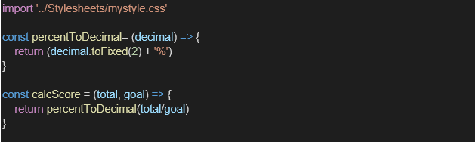

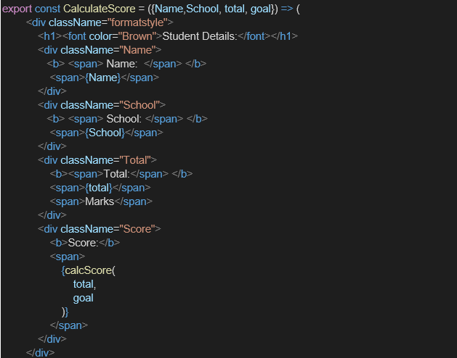

1. Create a Folder named Stylesheets and add a file named “mystyle.css” in order to add some styles to the components:

## Components/CalculatorScore.js:

import '../Stylesheets/mystyle.css'

const percentToDecimal = (decimal) => {

  return (decimal.toFixed(2) + '%');

};

const calcScore = (total, goal) => {

  return percentToDecimal(total / goal);

};

export const CalculateScore = ({ Name, School, total, goal }) => {

  return (

    <div className="formatstyle">

      <h1><font color="Brown">Student Details:</font></h1>

      <div className="Name">

        <b><span> Name: </span></b>

        <span>{Name}</span>

      </div>

      <div className="School">

        <b><span> School: </span></b>

        <span>{School}</span>

      </div>

      <div className="Total">

        <b><span> Total: </span></b>

        <span>{total}</span>

      </div>

      <div className="Score">

        <b><span> Score: </span></b>

        <span>{calcScore(total, goal)}</span>

      </div>

    </div>

  );

};

export default CalculateScore;

## Stylesheets/mystyle.css:

.Name {

  font-weight: 300;

  color: blue;

}

.School {

  color: crimson;

}

.Total {

  color: darkmagenta;

}

.formatstyle {

  text-align: center;

  font-size: large;

}

.Score {

  color: forestgreen;

}

## App.js:

import React from 'react';

import  CalculateScore  from './Components/CalculatorScore.js';

function App() {

  return (

    <div>

      <CalculateScore

        Name="Kaushic"

        School="St Patrick School"

        total={400}

        goal={5}

      />

    </div>

  );

}

export default App;

## Output:

